UNIVERSITY OF JAMMU
BHADERWAH CAMPUS


BACHELORS IN COMPUTER APPLICATION
(BCA-1ST SEMESTER)
PRACTICAL FILE
PROBLEM SOLVING USING C

SUBMITTED BY: SUBMITTED TO: HASHIR JAVED Mr. Abhay Khajuria
ACKNOWLEDGEMENT

I would like to express my gratitude to all those people who helped me to complete this practical file. I want to thank Department of computer science and IT for providing me all the tools and resources for the completion of my practical file.
I have further more to thank our respected teacher Mr. Abhay Khajuria who encouraged me to move ahead and complete my work in time. I am also bound to our Assistant Programmer Mr. Parvesh Singh whose help, simulating suggestions and encouragement helped me all the time during my work.
At last, I want to thank my classmates and friends for their help, support, interest and valuable hints. I want to thank once again all the above mentioned persons for their time and help.
Thank you.

HASHIR JAVED
BCA 1st Semester
113040008

CERTIFICATE

This is to certify that HASHIR JAVED student of BCA 1st semester bearing university Roll no. 113040008 has completed the required number of practicals of Problem solving using C under the guidance of class teacher MR. Abhay Khajuria from the Department of Computer science and IT, Bhaderwah campus, University of Jammu.

Signature
(Subject I/C)
1 | WAP to check whether the number is Armstrong or not.
2 | WAP to display Armstrong number between 1-1000.
3 | WAP to display the reverse number.
4 | WAP to display all factors of a number.
5 | WAP to display half pyramid.
6 | WAP to display full pyramid.
7 | WAP to C program to create prime number by creating a function.
8 | WAP to display prime numbers between two intervals using functions and for loop.
9 | WAP to check whether numbers can be expressed as the sum of two prime numbers.
10 | WAP to find sum of natural numbers using recursion.
11 | WAP to calculate factorial of a number using recursion.
12 | WAP to find HCF of two numbers.
13 | WAP to reverse a stack using recursion, without using any loop.
14 | WAP to calculate power of a number.
15 | WAP to find largest number in an array.
16 | WAP to check maximum and minimum size of an array.
17 | WAP to calculate average of all elements of an array.
18 | WAP to find common array elements between two arrays.
19 | WAP to copy all the elements of an array to another.
20 | WAP to find determinant of 2x2 Matrix.
21 | WAP to read the matrix and sum of matrix.
22 | WAP to read the matrix and the product of matrix.
23 | WAP to find the sum of all elements in each row.
24 | WAP to read the matrix and print its diagonals.
25 | WAP to display the sum of two matrix.
26 | WAP to display the subtraction of two matrix.
27 | WAP to display the multiplication of two matrix.
28 | WAP to check whether the two matrix are identical or not.
29 | WAP to interchange the rows of matrix.
30 | WAP to interchange the columns o f matrix.
31 | WAP to find string length without function in C.
32 | WAP to count character in a string.
33 | WAP to count vowels in strings.
34 | WAP to swap two strings.
35 | WAP to concatenate two strings.
36 | WAP to reverse words of a string .
37 | WAP for function without argument and with return value.
38 | WAP for function with argument and without return value.
39 | WAP for function with argument and with return value.
40 | WAP to use of call by value and call by reference.
Program 1:-WAP to check whether the number is Armstrong or not
#include<stdio.h>
#include<conio.h>
#include<math.h>
void main()
{
int a,a1,rmd,i=0,r=0;
clrscr();
printf("enter an integer:");
scanf("%d",&a);
a1=a;
for(a1=a;a1!=0;i++)
{
a1/=10;
}
for(a1=a;a1!=0;a1/=10)
{
rmd=a1%10;
r+= pow(rmd,i);
}
if((int)r==a)
printf("%d is an armstrong number",a);
else
printf("%d is not an armstrong number",a);
getch();
}

Output:-
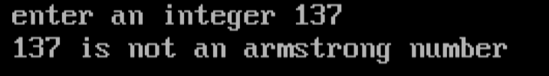

Program 2:- WAP to display Armstrong number between 1-1000.
#include <stdio.h>
#include <conio.h>

int main()
{
int num, originalNum, sum = 0, digit;
clrscr();

printf("Enter an integer: ");
scanf("%d", &num);

originalNum = num;

while (num > 0)
{
digit = num % 10;
sum += digit * digit * digit;
num /= 10;
}

if (sum == originalNum)
printf("%d is an Armstrong number.\n", originalNum);
else
printf("%d is not an Armstrong number.\n", originalNum);
getch();
return 0;
}
Output:-
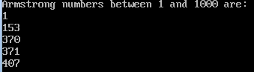

Program 3:- WAP to display the reverse number.
#include <stdio.h>
#include <conio.h>
int main()
{
int num, reversed = 0;
clrscr();
printf("Enter a number: ");
scanf("%d", &num);

while (num != 0)
{
reversed = reversed * 10 + num % 10;
num /= 10;
}
printf("Reversed number: %d", reversed);
getch();
return 0;
}
Output:-
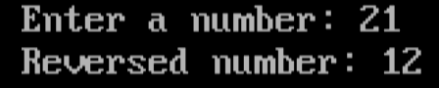

Program 4:- WAP to display all factors of a number.
#include <stdio.h>
#include <conio.h>
int main()
{
int num, i;
clrscr();
printf("Enter a number: ");
scanf("%d", &num);

printf("Factors of %d are:\n", num);
for (i = 1; i <= num; ++i)
{
if (num % i == 0)
{
printf("%d\n", i);
}
}
getch();
return 0;
}
Output:-
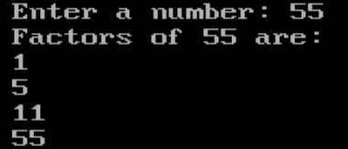
Program 5:- WAP to display half pyramid
#include <stdio.h>
#include <conio.h>
int main()
{
int rows, i, j;
clrscr();
printf("Enter number of rows: ");
scanf("%d", &rows);

for (i = 1; i <= rows; ++i)
{
for (j = 1; j <= i; ++j)
{
printf("%d ", i);
}
printf("\n");
}
getch();
return 0;
}
Output:-
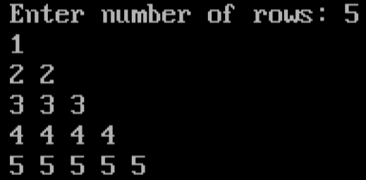
Program 6:- WAP to display full pyramid.
#include <stdio.h>
#include <conio.h>
int main()
{
int rows, i, k, space, num = 1;
clrscr();
printf("Enter number of rows: ");
scanf("%d", &rows);
for (i = 1, k = 0; i <= rows; ++i, k = 0)
{
for (space = 1; space <= rows - i; ++space)
{
printf(" ");
}
while (k != 2 * i - 1)
{
printf("%d ", num);
++k;
}
num++;
printf("\n");
} getch(); return 0; }
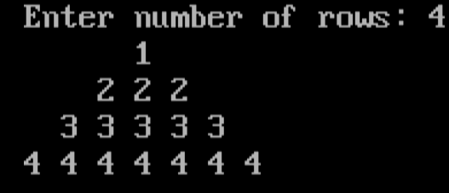
Output:-
Program 7:- WAP to C program to create prime number by creating a
function .
#include <stdio.h>
#include <conio.h>

int isPrime(int num);

int main()
{
int number;

clrscr();
printf("Enter a number: ");
scanf("%d", &number);

if (isPrime(number))
{
printf("%d is a prime number.", number);
} else
{
printf("%d is not a prime number.", number);
}

getch();
return 0;
}

int isPrime(int num)
{
int i;

if (num < 2)
{
return 0;
}

for (i = 2; i <= num / 2; ++i)
{
if (num % i == 0)
{
return 0;
}
}

return 1;
}
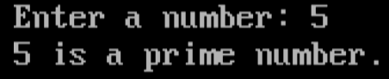
Output:-
Program 8:- WAP to display prime numbers between two intervals using functions and for loop.
#include <stdio.h>
#include <conio.h>

int isPrime(int num);

int main()
{
int start, end, i;

clrscr();
printf("Enter the start and end values for the interval: ");
scanf("%d %d", &start, &end);

printf("Prime numbers between %d and %d are:\n", start, end);
for (i = start; i <= end; ++i)
{
if (isPrime(i))
{
printf("%d\n", i);
}
}

getch();
return 0;
} c

int isPrime(int num)
{
int i, isPrimeFlag = 1;

if (num < 2)
{
isPrimeFlag = 0;
}

for (i = 2; i <= num / 2; ++i)
{
if (num % i == 0)
{
isPrimeFlag = 0;
break;
}
}

return isPrimeFlag;
}

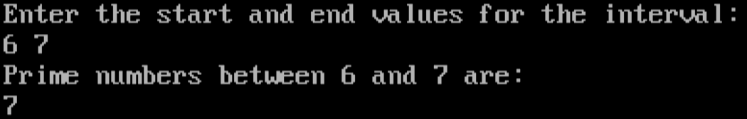
Output:-
Program 9:- WAP to check whether numbers can be expressed as the sum of two prime numbers.
#include <stdio.h>
#include <conio.h>

int isPrime(int num);

int main()
{
int number, i;
int flag = 0;

clrscr();
printf("Enter a number: ");
scanf("%d", &number);

for (i = 2; i <= number / 2; ++i)
{
if (isPrime(i)) {
if (isPrime(number - i))
{
flag = 1;
break;
}
}
}

if (flag)
{
printf("%d can be expressed as the sum of two prime numbers.", number);
}
else
{
printf("%d cannot be expressed as the sum of two prime numbers.", number);
}

getch();
return 0;
}

int isPrime(int num) {
int i, isPrimeFlag = 1;

if (num < 2) {
isPrimeFlag = 0;
}

for (i = 2; i <= num / 2; ++i) {
if (num % i == 0) {
isPrimeFlag = 0;
break;
}
}

return isPrimeFlag;
}
Output:-
Program 10:- WAP to find sum of natural numbers using recursion.
#include <stdio.h>
#include <conio.h>

int sumOfNaturalNumbers(int n);

int main()
{
int num;

clrscr();
printf("Enter a positive integer: ");
scanf("%d", &num);

printf("Sum of natural numbers from 1 to %d is: %d", num, sumOfNaturalNumbers(num));

getch();
return 0;
}

int sumOfNaturalNumbers(int n)
{
if (n == 0)
{
return 0;
}
else
{
return n + sumOfNaturalNumbers(n - 1);
}
}
Output:-

Program 11:- WAP to calculate factorial of a number using recursion.
#include <stdio.h>
#include <conio.h>

int factorial(int n);

int main()
{
int num;

clrscr();
printf("Enter a non-negative integer: ");
scanf("%d", &num);

printf("Factorial of %d is: %d", num, factorial(num));

getch();
return 0;
}
int factorial(int n)
{
if (n == 0 || n == 1)
{
return 1;
}
else
{
return n * factorial(n - 1);
}
}
Outout
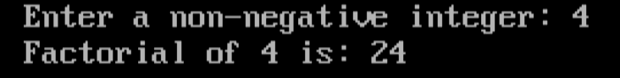
Program 12:- WAP to find HCF of two numbers.

#include <stdio.h>
#include <conio.h>

int findGCD(int num1, int num2);

int main()
{
int num1, num2;

clrscr();
printf("Enter two positive integers: ");
scanf("%d %d", &num1, &num2);

printf("GCD of %d and %d is: %d", num1, num2, findGCD(num1, num2));

getch();
return 0;
}

int findGCD(int num1, int num2)
{
while (num1 != num2)
{
if (num1 > num2)
num1 -= num2;
else
num2 -= num1;
}
return num1;
}
Output
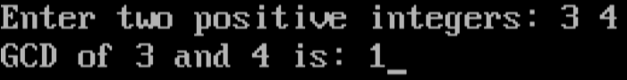

Program 13:- WAP to reverse a stack using recursion, without using any loop.
#include <stdio.h>
#include <conio.h>
#include <stdlib.h>
#define MAX_SIZE 100
struct Stack
{
int items[MAX_SIZE];
int top;
};
void initializeStack(struct Stack *s);
int isEmpty(struct Stack *s);
void push(struct Stack *s, int value);
int pop(struct Stack *s);
void reverseStack(struct Stack *s, int value);
int main()
{
int n,i;
struct Stack stack;
clrscr();
initializeStack(&stack);
printf("Enter the number of elements in the stack: ");
scanf("%d", &n);
printf("Enter the elements of the stack:\n");
for (i = 0; i < n; ++i)
{
int element;
scanf("%d", &element);
push(&stack, element);
}
reverseStack(&stack, 0);
printf("Reversed Stack:\n");
while (!isEmpty(&stack))
{
printf("%d\n", pop(&stack));
}
getch();
return 0;
}
void initializeStack(struct Stack *s)
{
s->top = -1;
}
int isEmpty(struct Stack *s)
{
return s->top == -1;
}
void push(struct Stack *s, int value)
{
if (s->top == MAX_SIZE - 1)
{
printf("Stack overflow\n");
return;
}
s->items[++s->top] = value;
}

int pop(struct Stack *s)
{
if (isEmpty(s))
{
printf("Stack underflow\n");
return -1;
}
return s->items[s->top--];
}
void reverseStack(struct Stack *s, int value)
{
if (!isEmpty(s))
{
int temp = pop(s);
reverseStack(s, temp);
push(s, value);
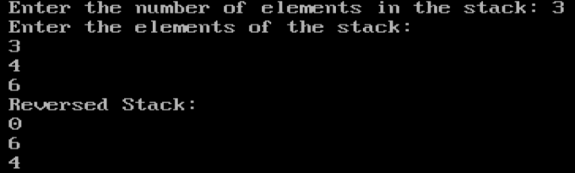
}
} output
Program 14:- WAP to calculate power of a number.
#include <stdio.h>
#include <conio.h>

int power(int base, int exponent);

int main()
{
int base, exponent;

clrscr();
printf("Enter base: ");
scanf("%d", &base);

printf("Enter exponent: ");
scanf("%d", &exponent);

printf("%d^%d = %d", base, exponent, power(base, exponent));

getch();
return 0;
}

int power(int base, int exponent) {
if (exponent == 0) {
return 1;
} else {
return base * power(base, exponent - 1);
}
}
Output
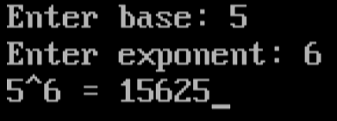
Program 15:- WAP to find largest number in an array.
#include <stdio.h>
#include <conio.h>

#define MAX_SIZE 100

int findLargest(int arr[], int size);

int main()
{
int arr[MAX_SIZE];
int size, i;

clrscr();
printf("Enter the size of the array: ");
scanf("%d", &size);

printf("Enter the elements of the array:\n");
for (i = 0; i < size; ++i)
{
scanf("%d", &arr[i]);
}

printf("The largest number in the array is: %d", findLargest(arr, size));

getch();
return 0;
}

int findLargest(int arr[], int size)
{
int max = arr[0], i;

for (i = 1; i < size; ++i)
{
if (arr[i] > max)
{
max = arr[i];
}
}

return max;
}
Output
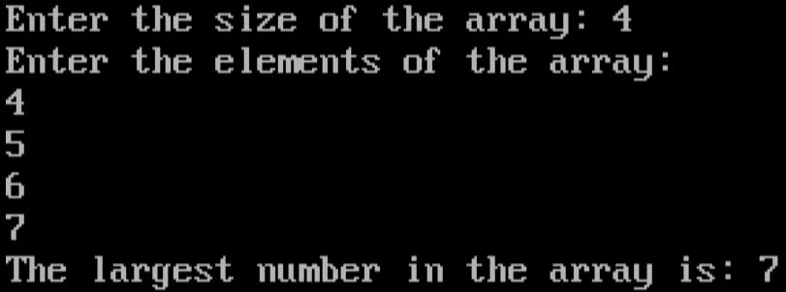
Program 16:- WAP to check maximum and minimum size of an array.
#include <stdio.h>
#include <conio.h>

#define MAX_SIZE 100

int main()
{
int arr[MAX_SIZE];

clrscr();

printf("Maximum size of the array: %d\n", MAX_SIZE);
printf("Minimum size of the array: 0");

getch();
return 0;
}
Output
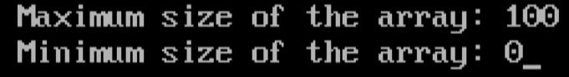
Program 17:- WAP to calculate average of all elements of an array.
#include <stdio.h>
#include <conio.h>

#define MAX_SIZE 100

float calculateAverage(int arr[], int size);

int main()
{
int arr[MAX_SIZE];
int size, i;

clrscr();
printf("Enter the size of the array: ");
scanf("%d", &size);

printf("Enter the elements of the array:\n");
for (i = 0; i < size; ++i)
{
scanf("%d", &arr[i]);
}

printf("Average of the array elements: %.2f", calculateAverage(arr, size));

getch();
return 0;
}

float calculateAverage(int arr[], int size)
{
int sum = 0, i;

for (i = 0; i < size; ++i)
{
sum += arr[i];
}

return (float)sum / size;
}
Output
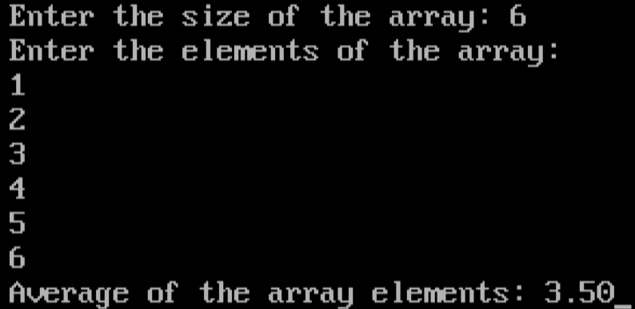
Program 18:- WAP to find common array elements between two arrays.
#include <stdio.h>
#include <conio.h>

#define MAX_SIZE 100

void findCommonElements(int arr1[], int size1, int arr2[], int size2);

int main()
{
int arr1[MAX_SIZE], arr2[MAX_SIZE];
int size1, size2, i;

clrscr();
printf("Enter the size of the first array: ");
scanf("%d", &size1);

printf("Enter the elements of the first array:\n");
for (i = 0; i < size1; ++i)
{
scanf("%d", &arr1[i]);
}

printf("Enter the size of the second array: ");
scanf("%d", &size2);

printf("Enter the elements of the second array:\n");

for (i = 0; i < size2; ++i) {
scanf("%d", &arr2[i]);
}

findCommonElements(arr1, size1, arr2, size2);

getch();
return 0;
}

void findCommonElements(int arr1[], int size1, int arr2[], int size2)
{
int i, j;
printf("Common elements between the two arrays:\n");

for (i = 0; i < size1; ++i) {
for (j = 0; j < size2; ++j) {
if (arr1[i] == arr2[j]) {
printf("%d\n", arr1[i]);
break;
}
}
}
}
Output
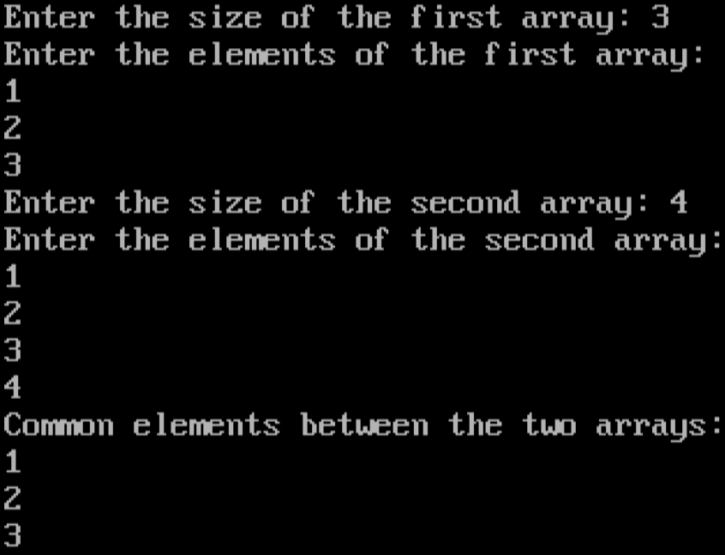
Program 19:- WAP to copy all the elements of an array to another.
#include <stdio.h>
#include <conio.h>

#define MAX_SIZE 100

void copyArray(int source[], int destination[], int size);

int main()
{
int sourceArray[MAX_SIZE], destinationArray[MAX_SIZE];
int size, i;

clrscr();
printf("Enter the size of the array: ");
scanf("%d", &size);

printf("Enter the elements of the array to be copied:\n");
for (i = 0; i < size; ++i)
{
scanf("%d", &sourceArray[i]);
}

copyArray(sourceArray, destinationArray, size);

printf("Elements copied to the destination array:\n");
for (i = 0; i < size; ++i)
{
printf("%d\n", destinationArray[i]);
}

getch();
return 0;
}

void copyArray(int source[], int destination[], int size)
{
int i;
for (i = 0; i < size; ++i)
{
destination[i] = source[i];
}
}
Output
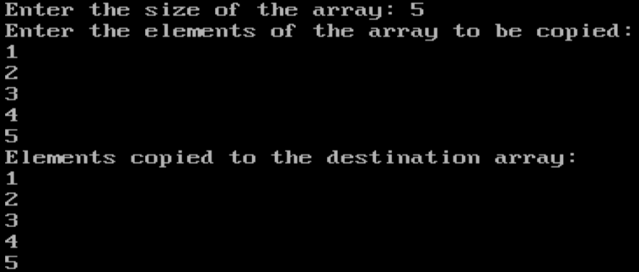

Program 20:- WAP to find determinant of 2x2 Matrix.
#include <stdio.h>
#include <conio.h>

int main()
{
int matrix[2][2];
int determinant, i, j;

clrscr();
printf("Enter the elements of the 2x2 matrix:\n");

for (i = 0; i < 2; ++i)
{
for (j = 0; j < 2; ++j)
{
scanf("%d", &matrix[i][j]);
}
}

determinant = matrix[0][0] * matrix[1][1] - matrix[0][1] * matrix[1][0];

printf("Determinant of the 2x2 matrix: %d", determinant);

getch();
return 0;
}
Output
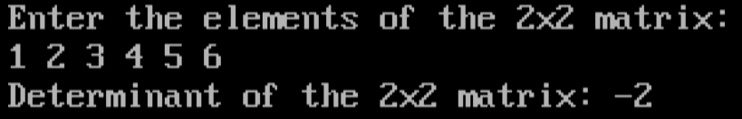

Program 21 :-WAP to read the matrix and sum of matrix
#include<stdio.h>
#include<conio.h>
void main()
{
int l1,l2,a,b;
int m1[100][100], m2[100][100], m3[100][100];
printf("Enter the size of the matrix : ");
scanf("%d %d",&a,&b);
printf("\nEnter the elements of the 1st matrix : \n");
for(l1=0;l1<a;l1++){
for(l2=0;l2<b;l2++){
printf("Enter element [%d,%d] : ",l1+1,l2+1);
scanf("%d",&m1[l1][l2]);
}
}
printf("\nEnter the elements of the 2nd matrix : \n");
for(l1=0;l1<a;l1++){
for(l2=0;l2<b;l2++){
printf("Enter element [%d,%d] : ",l1+1,l2+1);
scanf("%d",&m2[l1][l2]);
m3[l1][l2]=m1[l1][l2]+m2[l1][l2];
}
}
printf("The 1st matrix is : \n");
for(l1=0;l1<a;l1++){
for(l2=0;l2<b;l2++){
printf("%d\t",m1[l1][l2]);
}
printf("\n");
}
printf("The 2nd matrix is : \n");
for(l1=0;l1<a;l1++){
for(l2=0;l2<b;l2++){
printf("%d\t",m2[l1][l2]);
}
printf("\n");
}
printf("The solution to the addition of these two matrix :\n");
for(l1=0;l1<a;l1++){
for(l2=0;l2<b;l2++){
printf("%d\t",m3[l1][l2]);
}
printf("\n");
}
getch();
clrscr();
}

Program 22:- WAP to read the matrix and the product of matrix.
#include<stdio.h>
#include<stdio.h>
#include<conio.h>
void main()
{
int l1,l2,a,b;
int m1[100][100], m2[100][100], m3[100][100];
printf("Enter the size of the matrix : ");
scanf("%d %d",&a,&b);
printf("\nEnter the elements of the 1st matrix : \n");
for(l1=0;l1<a;l1++){
for(l2=0;l2<b;l2++){
printf("Enter element [%d,%d] : ",l1+1,l2+1);
scanf("%d",&m1[l1][l2]);
}
}
printf("\nEnter the elements of the 2nd matrix : \n");
for(l1=0;l1<a;l1++){
for(l2=0;l2<b;l2++){
printf("Enter element [%d,%d] : ",l1+1,l2+1);
scanf("%d",&m2[l1][l2]);
m3[l1][l2]=m1[l1][l2]-m2[l1][l2];
}
}
printf("The 1st matrix is : \n");
for(l1=0;l1<a;l1++){
for(l2=0;l2<b;l2++){
printf("%d\t",m1[l1][l2]);
}
printf("\n");
}
printf("The 2nd matrix is : \n");
for(l1=0;l1<a;l1++){
for(l2=0;l2<b;l2++){
printf("%d\t",m2[l1][l2]);
}
printf("\n");
}
printf("The solution to the subtraction of these two matrix :\n");
for(l1=0;l1<a;l1++){
for(l2=0;l2<b;l2++){
printf("%d\t",m3[l1][l2]);
}
printf("\n");
}
getch();
clrscr();
}

Program 23:- WAP to find the sum of all elements in each row.
#include<stdio.h>
#include<conio.h>
void main()
{
int l1,l2,l3,a,b;
int m1[100][100], m2[100][100], m3[100][100];
printf("Enter the size of the matrix : ");
scanf("%d %d",&a,&b);
printf("\nEnter the elements of the 1st matrix : \n");
for(l1=0;l1<a;l1++){
for(l2=0;l2<b;l2++){
printf("Enter element [%d,%d] : ",l1+1,l2+1);
scanf("%d",&m1[l1][l2]);
}
}
printf("\nEnter the elements of the 2nd matrix : \n");
for(l1=0;l1<a;l1++){
for(l2=0;l2<b;l2++){
printf("Enter element [%d,%d] : ",l1+1,l2+1);
scanf("%d",&m2[l1][l2]);
}
}
printf("The 1st matrix is : \n");
for(l1=0;l1<a;l1++){
for(l2=0;l2<b;l2++){
printf("%d\t",m1[l1][l2]);
}
printf("\n");
}
printf("The 2nd matrix is : \n");
for(l1=0;l1<a;l1++){
for(l2=0;l2<b;l2++){
printf("%d\t",m2[l1][l2]);
}
printf("\n");
}
printf("The product of these two matrix :\n");
for(l1=0;l1<a;l1++){
for(l2=0;l2<b;l2++){
m3[l1][l2]=0;
for(l3=0;l3<b;l3++){
m3[l1][l2]+=m1[l1][l3]*m2[l3][l2];
}
printf("%d\t",m3[l1][l2]);
}
printf("\n");
}
getch();
clrscr();
Program 24 :- WAP to read the matrix and print its diagonals.
#include<stdio.h>
#include<conio.h>
void main()
{
int l1,l2,a,b, bool=1;
int m1[100][100], m2[100][100], m3[100][100];
printf("Enter the size of the matrix : ");
scanf("%d %d",&a,&b);
printf("\nEnter the elements of the 1st matrix : \n");
for(l1=0;l1<a;l1++){
for(l2=0;l2<b;l2++){
printf("Enter element [%d,%d] : ",l1+1,l2+1);
scanf("%d",&m1[l1][l2]);
}
}
printf("\nEnter the elements of the 2nd matrix : \n");
for(l1=0;l1<a;l1++){
for(l2=0;l2<b;l2++){
printf("Enter element [%d,%d] : ",l1+1,l2+1);
scanf("%d",&m2[l1][l2]);
m3[l1][l2]=m1[l1][l2]+m2[l1][l2];
}
}
printf("The 1st matrix is : \n");
for(l1=0;l1<a;l1++){
for(l2=0;l2<b;l2++){
printf("%d\t",m1[l1][l2]);
}
printf("\n");
}
printf("The 2nd matrix is : \n");
for(l1=0;l1<a;l1++){
for(l2=0;l2<b;l2++){
printf("%d\t",m2[l1][l2]);
}
printf("\n");
}
for(l1=0;l1<a;l1++){
for(l2=0;l2<b;l2++){
if(m1[l1][l2] != m2[l1][l2]){
bool=0;
break;
}
}
}
if(bool==1){
printf("The matrices are identical");
}
else{
printf("The matrices are not identical");
}
getch();
clrscr();
}

Program25:- WAP to display the sum of two matrix.
#include<stdio.h>
#include<conio.h>
void main()
{
int a,b,l1,l2,x;
int m[100][100],r1,r2;
printf("Enter the number of rows and columns of the matrix : ");
scanf("%d %d",&a,&b);
m[a][b];
printf("\nEnter the elements of the matrix : \n");
for(l1=0;l1<a;l1++){
for(l2=0;l2<b;l2++){
printf("Enter element [%d,%d] : ",l1+1,l2+1);
scanf("%d",&m[l1][l2]);
x+=m[l1][l2];
}
}
printf("The entered matrix is : \n");
for(l1=0;l1<a;l1++){
for(l2=0;l2<b;l2++){
printf("%d\t",m[l1][l2]);
}
printf("\n");
}
printf("The rows to be interchanged : \n");
scanf("%d %d",&r1,&r2);
for(l1=0;l1<a;l1++){
x=m[r1-1][l1];
m[r1-1][l1]=m[r2-1][l1];
m[r2-1][l1]=x;
}
printf("\nMatrix after interchanging rows : \n");
for(l1=0;l1<a;l1++){
for(l2=0;l2<b;l2++){
printf("%d\t",m[l1][l2]);
}
printf("\n");
}
getch();
clrscr();
}

Program 26:- WAP to display the subtraction of two matrix.
#include<stdio.h>
#include<conio.h>
void main()
{
int a,b,l1,l2,x;
int m[100][100],r1,r2;
printf("Enter the number of rows and columns of the matrix : ");
scanf("%d %d",&a,&b);
m[a][b];
printf("\nEnter the elements of the matrix : \n");
for(l1=0;l1<a;l1++){
for(l2=0;l2<b;l2++){
printf("Enter element [%d,%d] : ",l1+1,l2+1);
scanf("%d",&m[l1][l2]);
x+=m[l1][l2];
}
}
printf("The entered matrix is : \n");
for(l1=0;l1<a;l1++){
for(l2=0;l2<b;l2++){
printf("%d\t",m[l1][l2]);
}
printf("\n");
}
printf("The columns to be interchanged : \n");
scanf("%d %d",&r1,&r2);
for(l1=0;l1<a;l1++){
x=m[l1][r1-1];
m[l1][r1-1]=m[l1][r2-1];
m[l1][r2-1]=x;
}
printf("\nMatrix after interchanging columns : \n");
for(l1=0;l1<a;l1++){
for(l2=0;l2<b;l2++){
printf("%d\t",m[l1][l2]);
}
printf("\n");
}
getch();
clrscr();
}

Output:-

Program 27 :- WAP to display the multiplication of two matrix.
#include<stdio.h>
#include<conio.h>
void main()
{
char l[100];
int l1,size=0;
printf("Enter some line (without space) : \n");
scanf("%s",l);
for(l1=0;l[l1]!='\0';l1++){
size++;
}
printf("Length of given string is : %d",size);
getch();
clrscr();
}

Output:-

Program 48:- WAP to check whether the two matrix are identical or not.
#include<stdio.h>
#include<conio.h>
#include<string.h>
void main()
{
char l[100];
int l1,size=0;
printf("Enter some line : ");
scanf("%[^\n]",&l);
for(l1=0;l1<strlen(l);l1++){
if(l[l1]!=' '){
size++;
}
}
printf("Total number of character in this string is : %d",l1);
getch();
clrscr();
}

Output:-

Program 29:- WAP to interchange the rows of matrix.
#include<stdio.h>
#include<conio.h>
void main()
{
char l[100];
int l1,v=0;
printf("Enter some line : ");
scanf("%[^\n]",&l);
for(l1=0;l[l1];l1++){
if(l[l1]=='a'||l[l1]=='e'||l[l1]=='i'||
l[l1]=='o'||l[l1]=='u'||l[l1]=='A'||
l[l1]=='E'||l[l1]=='I'||l[l1]=='O'||l[l1]=='U'){
v++;
}
}
printf("Total number of vowels in this string are : %d",v);
getch();
clrscr();
}

Output:-

Program 30:- WAP to interchange the columns o f matrix.
#include<stdio.h>
#include<conio.h>
#include<string.h>
void main()
{
char s1[100], s2[100], s3[100];
printf("Enter the first string : ");
gets(s1);
printf("Enter the second string : ");
gets(s2);
strcpy(s3,s1);
strcpy(s1,s2);
strcpy(s2,s3);
printf("After swaping the two : \n");
printf("First string : %s\nSecond string : %s",s1,s2);
getch();
clrscr();
}

Program 31 :-WAP to find string length without function in C
#include<stdio.h>
#include<conio.h>
#include<string.h>
void main()
{
char s1[100], s2[100];
printf("Enter the first string : ");
gets(s1);
printf("Enter the second string : ");
gets(s2);
strcat(s1,s2);
printf("\nAfter concatenation : %s",s1);
getch();
clrscr();
}

Program 32 :-WAP to count character in a string.
#include<stdio.h>
#include<conio.h>
#include<string.h>
void main()
{
char s1[100];
printf("Enter some words : ");
gets(s1);
strrev(s1);
printf("\nAfter reversing : %s",s1);
getch();
clrscr();
}

Program 33:- WAP to count vowels in strings.
#include<stdio.h>
#include<conio.h>
int add();
void main()
{
int x;
x=add();
printf("Total : %d",x);
getch();
clrscr();
}
int add()
{
int a,b;
printf("Enter the value of a and b : ");
scanf("%d %d",&a,&b);
return a+b;
}

Program 34 :- WAP to swap two strings.
#include<stdio.h>
#include<conio.h>
void greet(char *name){
printf("Hello, %s!\n",name);
}
void main()
{
char name[100];
printf("Enter your name : ");
scanf("%s",name);
greet(name);
getch();
clrscr();
}

Program 35:- WAP to concatenate two strings.
#include<stdio.h>
#include<conio.h>
int sum(int a,int b)
{
return a+b;
}
void main()
{
int a,b,x;
printf("Enter the two numbers : ");
scanf("%d %d",&a,&b);
x=sum(a,b);
printf("The sum of these two is : %d",x);
getch();
clrscr();
}

Program 36:- WAP to reverse words of a string .
#include<stdio.h>
#include<conio.h>
void swap(int a,int b);
void main()
{
int n1=22,n2=33;
swap(n1,n2); //pass by values
printf("\nInside main function : \nn1=%d n2=%d",n1,n2);
getch();
clrscr();
}
//function that swaps the two values
void swap(int a,int b){
int t;
t=a;
a=b;
b=t;
printf("inside swap function : \na=%d b=%d",a,b);
}

Output:-

Program 37:- WAP for function without argument and with return value.
#include<stdio.h>
#include<conio.h>
void main()
{
int a[100],l,n,mn,mx;
printf("Enter the number of elements in the array : ");
scanf("%d",&n);
for(l=0;l<n;l++){
printf("Enter the element %d : ",l+1);
scanf("%d",&a[l]);
}
mn=mx=a[0];
for(l=1;l<n;l++){
if(mn>a[l])
mn=a[l];
if(mx<a[l])
mx=a[l];
}
printf("Maximum : %d",mx);
printf("\nMinimum : %d",mn);
getch();
clrscr();
}
Program 38:- WAP for function with argument and without return value.
#include<stdio.h>
#include<conio.h>
void main()
{
char operation;
double n1, n2;
printf("Enter an operator (+, -, *, /): ");
scanf("%c", &operation);
printf("Enter two operands: ");
scanf("%lf %lf",&n1, &n2);
switch(operation)
{
case '+':
printf("%.1lf + %.1lf = %.1lf",n1, n2, n1+n2);
break;
case '-':
printf("%.1lf - %.1lf = %.1lf",n1, n2, n1-n2);
break;
case '*':
printf("%.1lf * %.1lf = %.1lf",n1, n2, n1*n2);
break;
case '/':
printf("%.1lf / %.1lf = %.1lf",n1, n2, n1/n2);
break;
default:
printf("Error! operator is not correct");
}
getch();
clrscr();
}

Program 39:- WAP for function with argument and with return value.
#include<stdio.h>
#include<conio.h>
void main()
{
int n;
printf("\n enter the month number : ");
scanf("%d",&n);
switch(n)
{
case 1:
printf("Month is : January");
break;
case 2:
printf("Month is : February");
break;
case 3:
printf("Month is : March");
break;
case 4:
printf("Month is : April");
break;
case 5:
printf("Month is : May");
break;
case 6:
printf("Month is : June");
break;
case 7:
printf("Month is : July");
break;
case 8:
printf("Month is : August");
break;
case 9:
printf("Month is : September");
break;
case 10:
printf("Month is : October");
break;
case 11:
printf("Month is : November");
break;
case 12:
printf("Month is : December");
break;
default :
printf("Error\ninvalid input");
}
getch();
clrscr();
}

Output:-

Program 40:- WAP to use of call by value and call by reference.
#include<stdio.h>
#include<conio.h>
#include<string.h>
struct students{
int rollno;
char name[30];
char address[30];
char sec;
};
void main()
{
int i;
struct students stu[30];
printf("Enter the details of the students\n");
for(i=0;i<3;i++)
{
printf("\nEnter the details of the student %d\n",i+1);
printf("Enter the rollno. ");
scanf("%d",&stu[i].rollno);
fflush(stdin);
printf("Enter the name ");
gets(stu[i].name);
printf("Enter the a

